**Ask**

Business task: Analyze bicycle renting data from January 2022 to December 2022 to identify patterns that differentiates annual members and casual riders who use Cyclistic bikes. By finding these patterns, strategies may be proposed to convert casual riders into annual members.

**Prepare**

Description of sources: With the consent of the Motivate International Inc., trip data of a fictional company Cyclistic has been provided. The data in question spans each month in the year of 2022. Each month in this overall dataset contains several fields, including ride_id (unique identifier for individual ride), rideable_type (kind of bike used), started_at, ended_at, start_station_name (where departure occurred), start_station_id (unique identifier for start station), end_station_name, end_station_id, start_lat (latitude of start station), start_lng (longitude of start station), end_lat, end_lng, member_casual (specifies if specific ride was done by a casual or member user).

**Process**

Several changes were made to the data to make the final analysis clean.

1. Upon examining the data, it was discovered that some station IDs mapped to more than one station name. To make the names consistent, an algorithm written in Python was created to standardize each of the names, based on the most common name for each ID.
2. Misspellings were checked and changed in rideable_type and member_casual
   1. To do so, filter out duplicates in each column. If there is a misspelling, change it appropriately. If it doesn’t belong, delete the row.
3. Replace empty spaces with “NULL”
4. Organize data
   1. In this chronological sequence
      1. ended_at with oldest to newest
      2. started_at with oldest to newest
      3. member_casual
5. Calculating new data
   1. A started_at column was created, specifying the length of each ride
      1. Difference between started_at and ended_at
   2. A day_of_week column was created, specifying the day of the week each ride started
      1. Using WEEKDAY function

**Analyze**

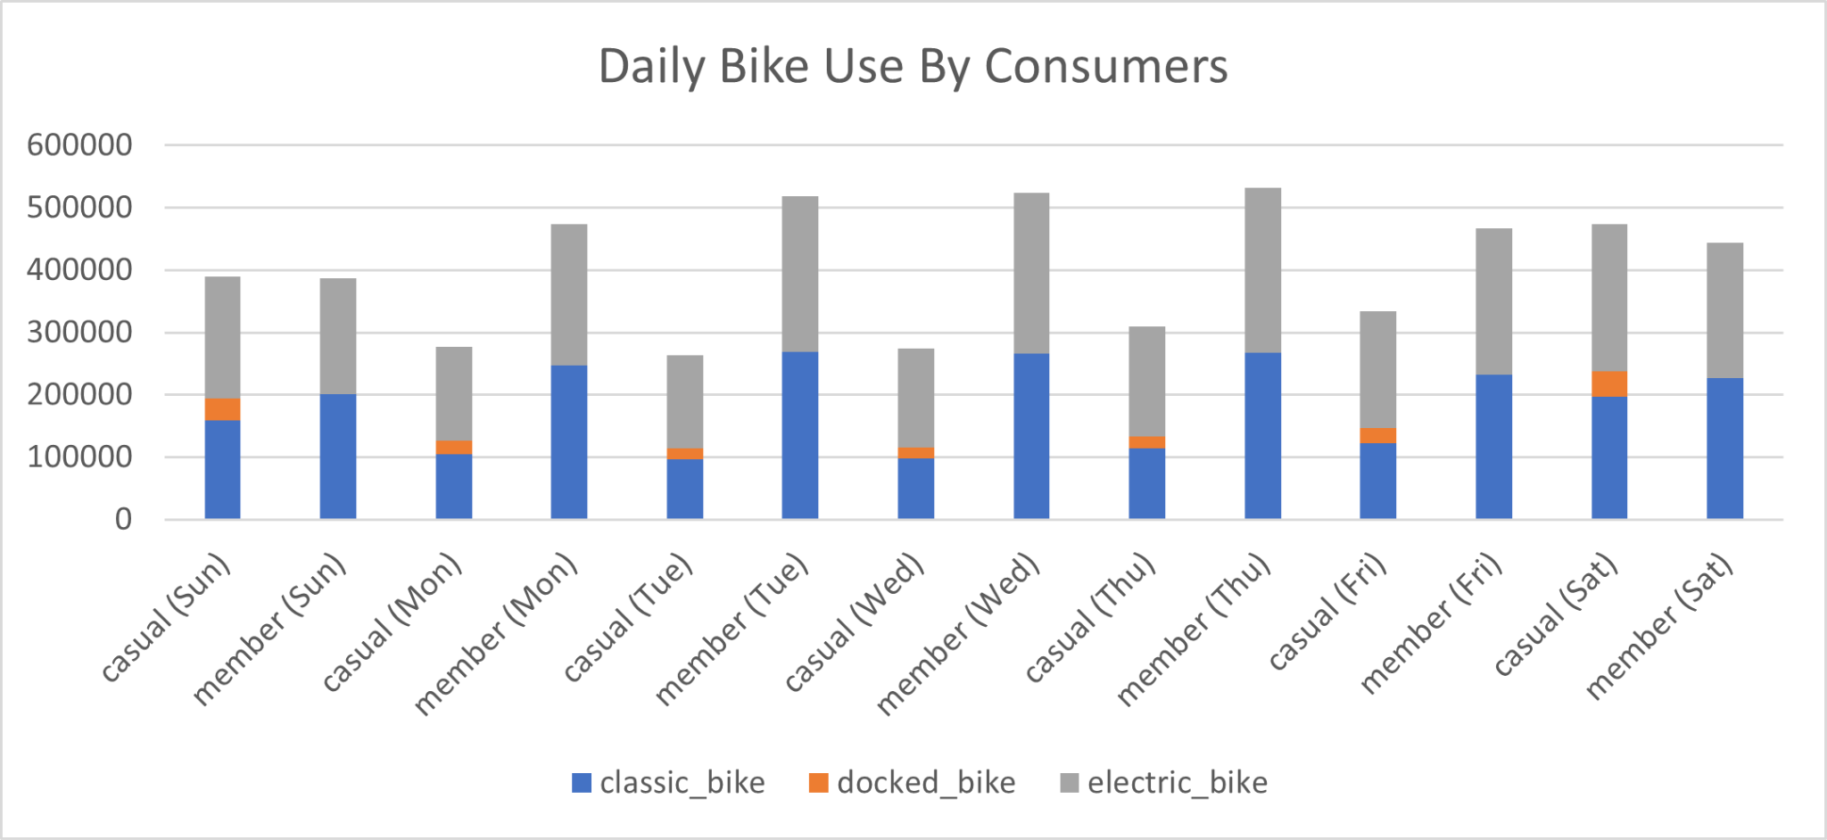

The above graph illustrates the overall daily bike use by consumers. The data is mapped over the course of the week, each day is divided into customer types (casual and member), and the portions of type of bike are illustrated by the different colors.

Takeaways:

1. Docked bikes do not take a large portion of the bike usage. However, only casual members have used docked bikes. This likely either means that docked bikes are an impossible function for member users, and/or casual users are unaware that they are being charged for the Cyclistic services. This may be something to consider in a business model.
2. The amount of casual bikers per week is higher on the weekends than on the weekdays. This implies that casual bikers tend to ride bikes recreationally, since they may otherwise be working on the weekdays, as opposed to when people are typically free on the weekends.
3. Although somewhat marginal, casual riders tend to prefer electronic bikes, and member riders tend to prefer classic bikes. This will affect how each group is treated (perhaps in advertising).

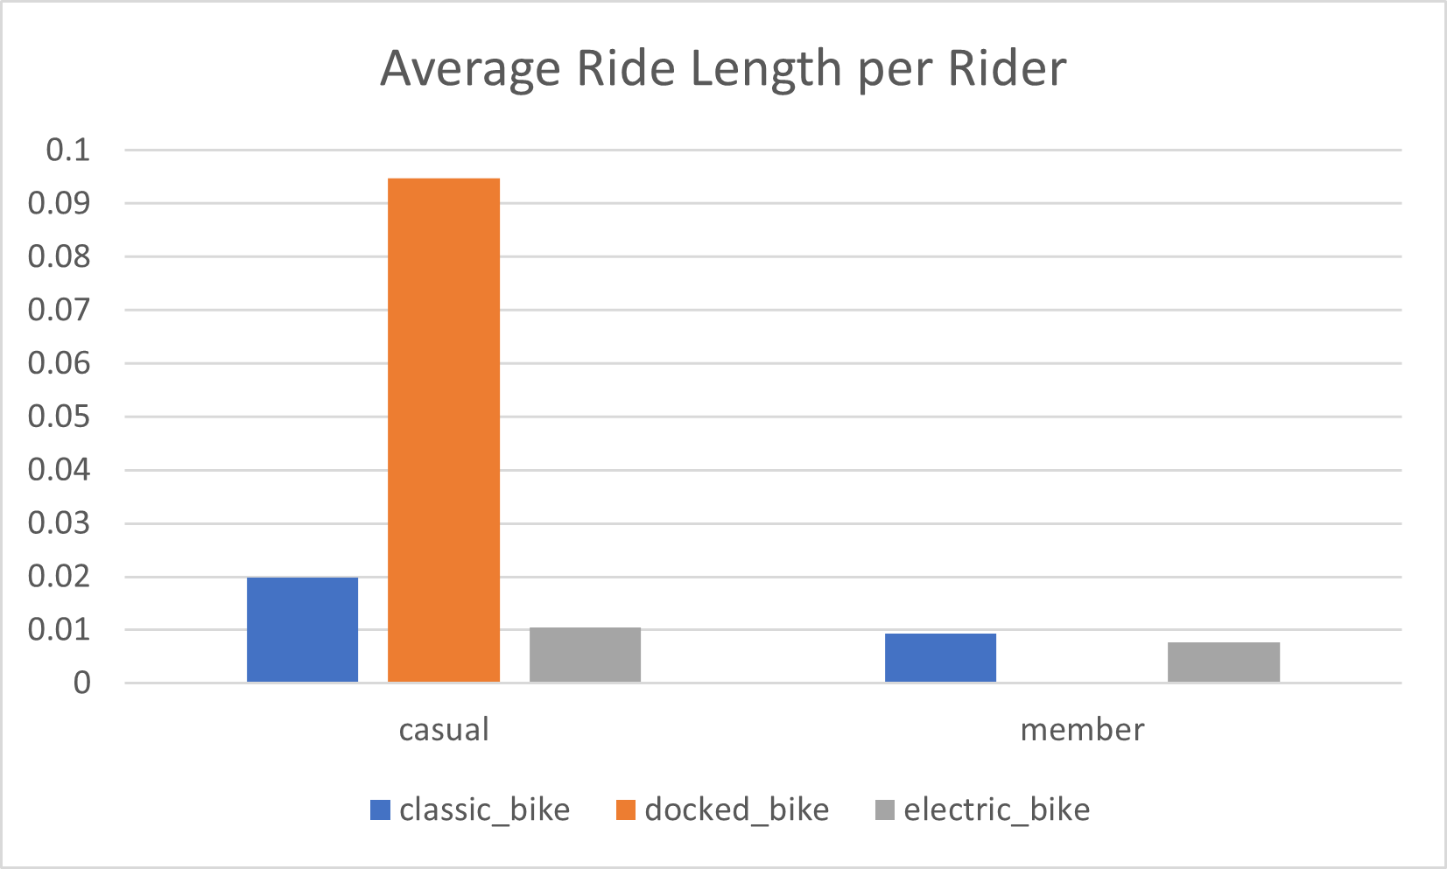

The above bar graph illustrates the average ride length (in days) of casual and member riders, subdivided into the types of bikes they use, respectively.

Takeaways:

1. For casual users, the docked bike is a significant outlier in the average length time, across the board. This may be due to unawareness on the casual users’ part that their bike is still technically on the clock as soon as they park their ride. This may be something to consider.
2. For both casual and member users, the average length time for a classic bike is longer than the electric bike. This is to be expected, as electric bikes tend to be faster for the ordinary person, meaning they can arrive at their destination quicker.
3. Casual riders also take longer rides, on average, relative to their member counterparts. This may imply the use of biking recreationally (having no destination in mind besides the journey), rather than getting someone specific. Member riders may have shorter rides because of their need to get to specific places (such as work and home). This is supported by the previous graph, illustrating that member riders use marginally more rides on the weekdays, rather than the weekends (although they may still use their bikes on the weekends).

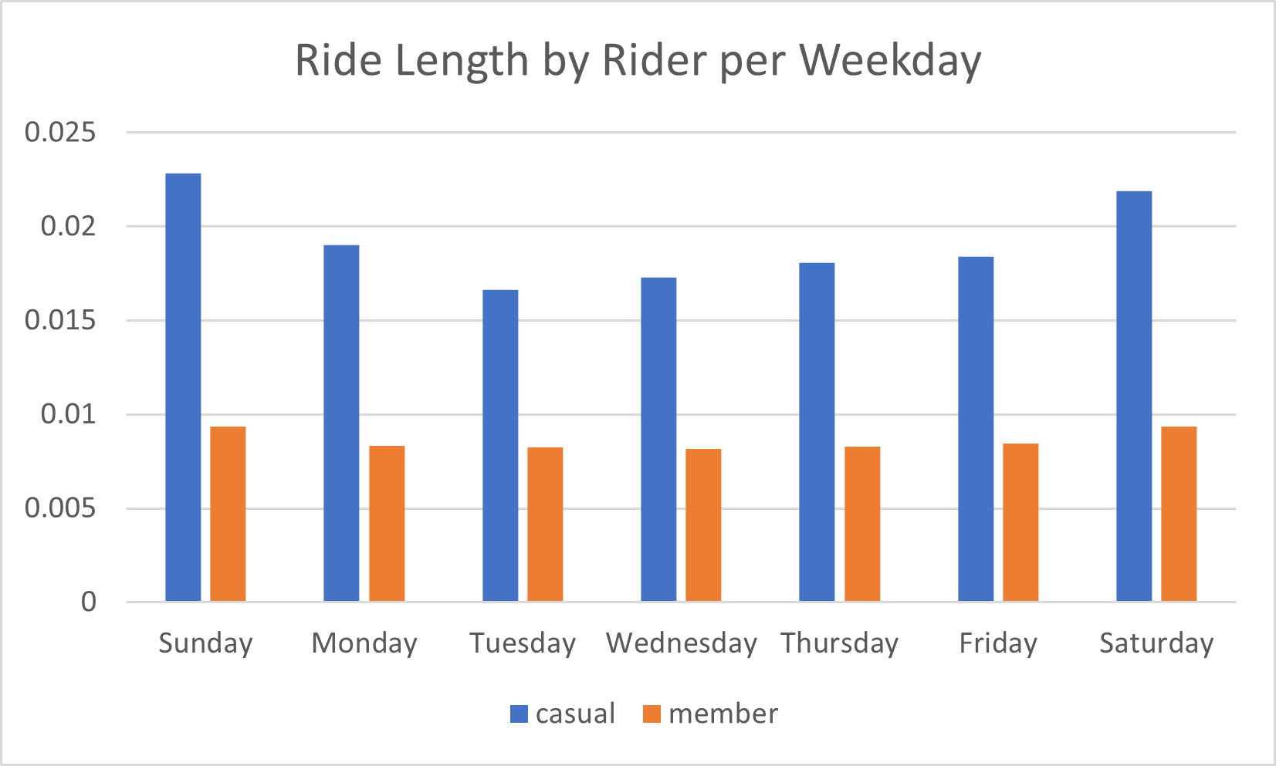

The above graph simply illustrates the average ride length by casual and member riders per day of the week. As shown, casual members tend to ride longer, whereas member riders tend to take shorter rides. This is something to consider.